Spraying Sunflower in Ukraine using DJI Agras T16

Agriculture in Ukraine is one of the most important branches of its economy due to variety of climatic and demographic reasons. The agriculturally used areas take more than 69% of Ukrainian territory. In 2019 sunflower was grown on the territory of 5.5 million of hectares and was used mostly for the production of sunflower oil. Ukraine is one of the leaders in the production of sunflower oil in the world and this is one of the key export oriented products in Ukrainian Economy, according to the results of 2019, Ukraine ranks first in the world in the export of sunflower oil (4.3 billion USD) and sunflower meal (0,97 billion USD).
Today we intend to introduce you how our partner in Ukraine sprayed chemicals for the sunflower and share with you the details.

*1. Purpose of the Spray
We have used drone spraying for fungicides implementation,
- rust on sunflower - Puccinia helianthi Schw
- septoria on sunflower
- sclerotiniosis on sunflower
- downy mildew on sunflower
Also we separately sprayed microelements (boron) as fertilizers.

*2. Info of the Environment
Date of Spray | 26.06.2020 | Location | Boryspil region, Velika oleksandrivka
Type of Terrain | plain | Temperature(℃) | 25℃
Total sprayed Area(ha.) | 2.04 ha | Humidity | 54%
Wind speed(m/s) | 2m/s | Wind direction | western

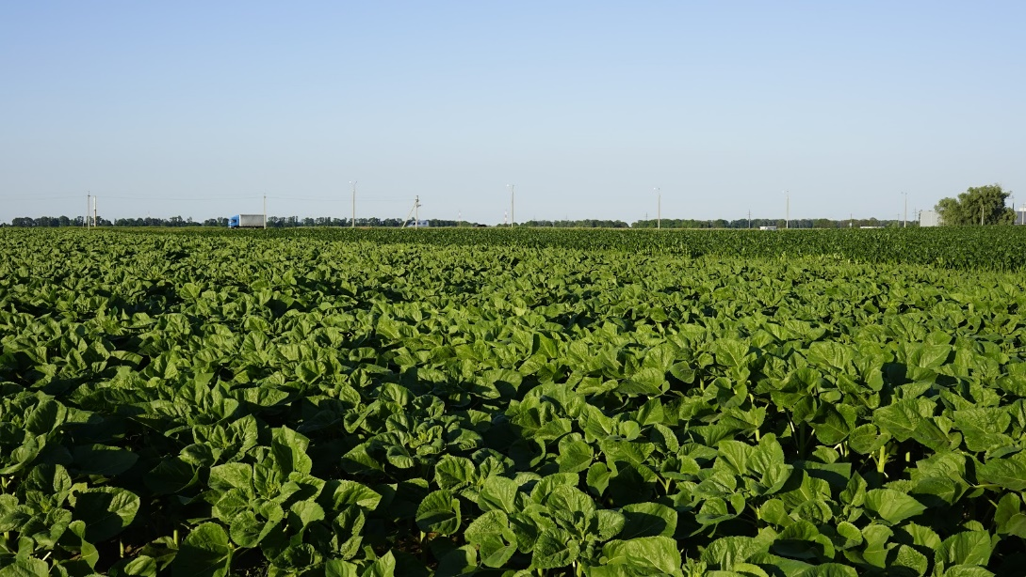

*3. Operation Parameters
Type of Drone | Agras t16 | Firmware Version | 2.01.0312
Operation mode | Intelligent Flight Planning | Operation Speed | 6m/s
Operation height(from the top of the crop) | 2.5 m | Line spacing/width | 6.5m
Liquid amount sprayed per hectare (or per MU) | 5 L | Nozzle type | РОса AM. 0075. SB (P. 03. 0.3)
Notes: Nozzle type of РОса AM. 0075. SB (P. 03. 0.3) is not recommended by DJI officially, so the spraying effect should be tested. However, DJI still suggests the user only use the nozzles listed on DJI official website.

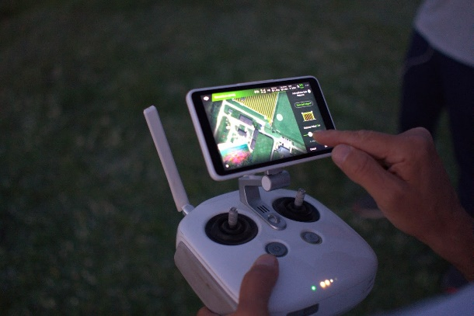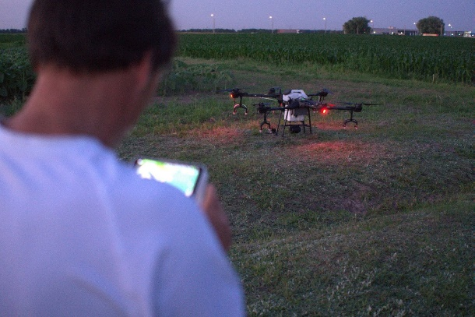

*4. Info of Chemicals
Chemical commercial name | Formulation | Active ingredient and the percentage | Chemical amount(g/ml) used per hectare
Defenda DOT  https://defenda.com.ua/en/product/dot | 80 g/L of Cyproconazole;  250 g/L of Propiconazole | Emulsion Concentrate | 500
Defenda Stark  https://defenda.com.ua/en/product/stark-ks | Azoxystrobin, 250 g/L | Suspension Concentrate | 750
Basfoliar Borough SL  https://binfield.ua/en/product/basfoliar-boro-sl | … | boron11% | 1000
Notes: fertilizer mission of Basfoliar Borough SL was separately sprayed.

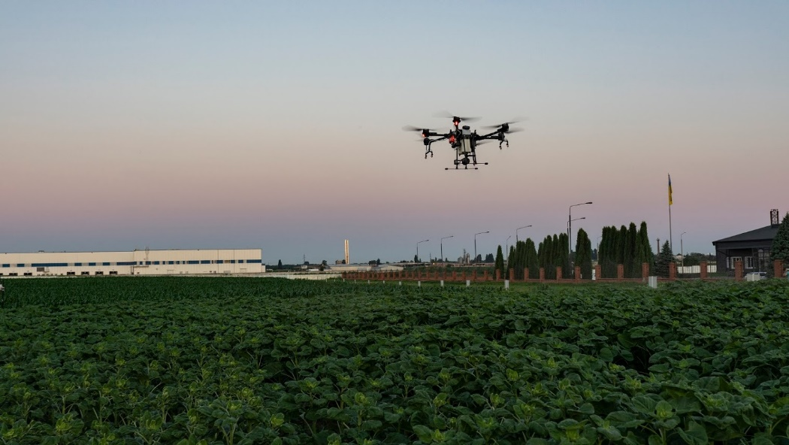

5. Briefly compare the difference between drone, manual, and other traditional equipment.
It was impossible to for ground equipment to enter into the field of sunflower since the crops are too high and existing equipment could damage them. Renting of higher equipment was not possible and economically non-effective.
Boron deficiency was found on the sunflower, and drone is used to urgently spray necessary amount of microelement to solve this issue.

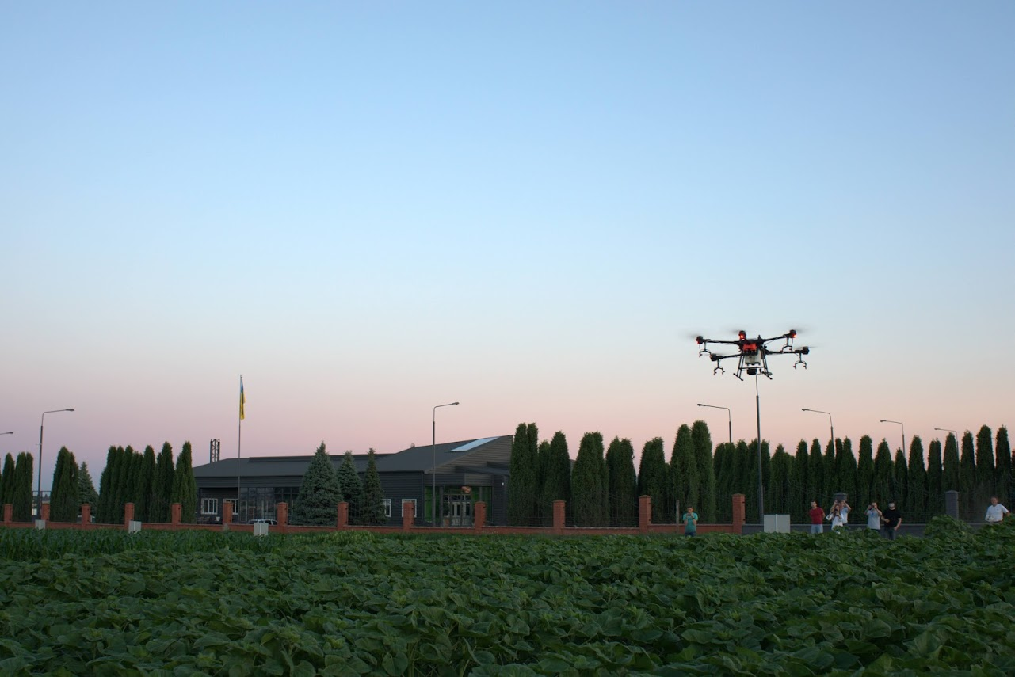

*6. Conclusion
First and a great feedback from the field owner is that boron deficiency was already solved, and within a weak damaged areas was cleared from the plants. We continued to collect data from the field specialists about signs of damage by fungi, there are no signs.
Field owner agreed on the continue of the drone use and we have already more flights planned with other chemicals and other plants.

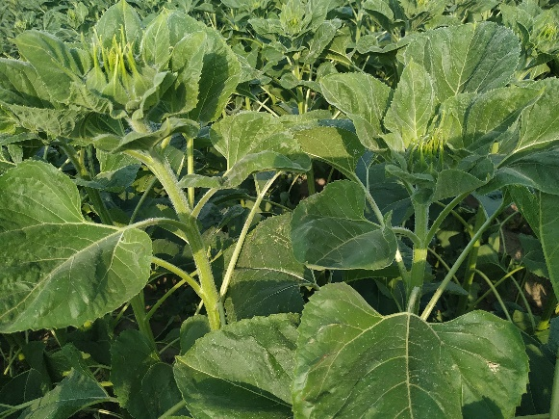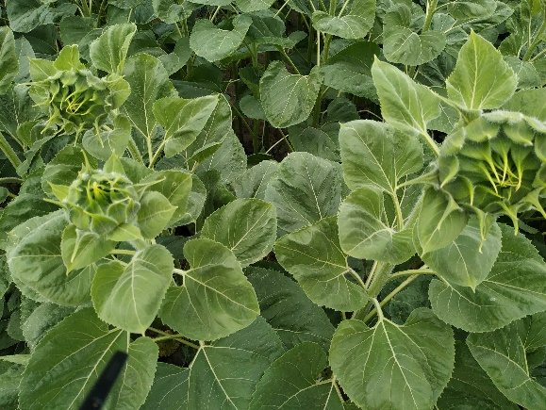
Sunflower plan before(left) and after(right) microelement
*7. Service team info
My company name is DroneUA, Aviaplaza.
We do work with drone agriculture implementation for 6 years already. Our team has 33 members, from drone pilots to data science specialists, to solve almost every question regarding drone services or data imagery protection for our clients. Collaboration with big names in agriculture, like Syngenta, Bayer, BASF and etc. helps us to start collaboration with decent numbers of agriculture producers and obtains experience from this collaboration. At the same time we have started to look into Drone spraying opportunities and already have several teams around Ukraine that achieved productivity of 100 hectares of spraying per day per drone.
Contact person：Valerii Iakovenko
Contact info（phone or email）+380955555582 iakovenko@drone.ua

Warm prompt: the content and parameters provided here are just for reference. You should adjust the operation mode and the parameters and use a correct way to spray your field according to the different weather, the crop characters, the habit or history of using chemicals(you could change other chemicals in case that the resistance occurs), etc. If you are not sure what operation parameters you will choose or not sure about the spraying efficacy, then you should firstly do a small plot test in this field before a big area spray.

