DJI Agras T16 sprayed Sugar Cane in Chiapas, Mexico

En México una de las actividades agrícolas más importantes es la productividad de caña de azúcar la cual ocupa el segundo lugar de importancia tan solo por debajo del Maíz; en el Estado de Chiapas no es la excepción, donde la producción de caña de azúcar ha crecido un 13% durante los últimos 10 años, colocándose en 2020 en el 4to lugar nacional de mayor cosecha con una producción cercana a los 2,362,929 toneladas en 34,392 hectáreas.
(In Mexico, one of the most important agricultural activities is the production of sugarcane, which ranks second in the importance only below Corn; In the State of Chiapas, the production of sugar cane has grown by 13% during the last 10 years, placing in the 4th place in the country with the highest harvest close to 2,362,929 tons in 34,392 hectares, in 2020)
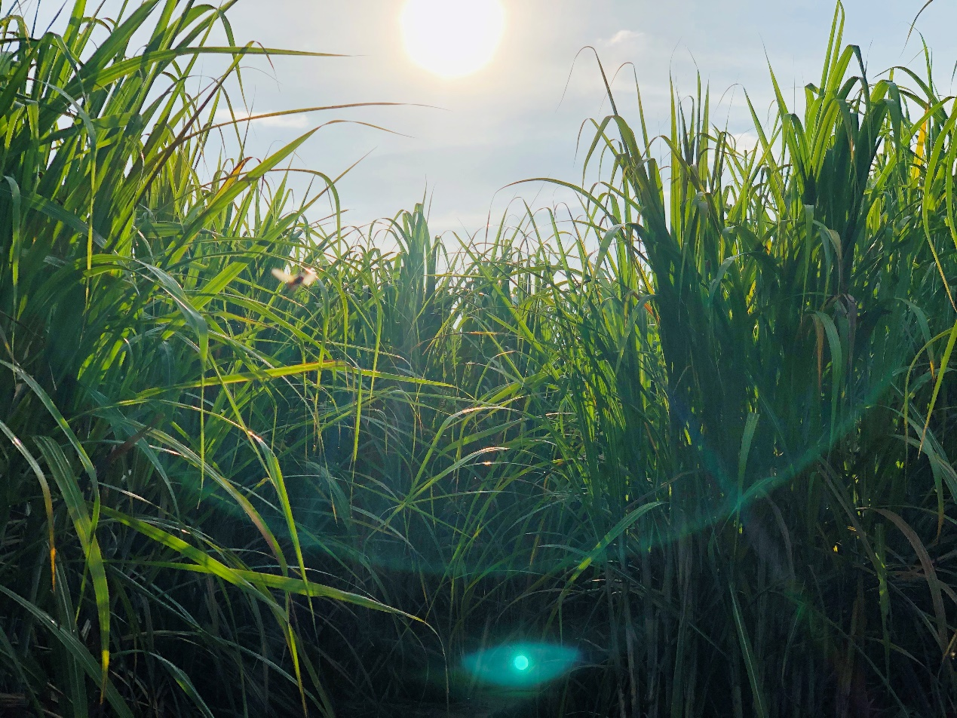
Entre las acciones que se han puesto en marcha para obtener un mayor crecimiento productivo se encuentra el combate a la plaga denominada “Salivazo o Mosca Pinta”; una de las más perjudiciales para la producción de caña de azúcar que puede llegar a reducir la extracción de azúcar hasta en un 60% si no se atiende a tiempo.
(One of the actions that have been put in place to obtain greater productive growth is the fight against the plague called "Spittlebug or Fly Pinta", one of the most damaging for sugarcane production that can reduce sugar extraction by up to 60% if it is not attended on time.)
Para este caso de estudio en Drones Hobbytuxtla tuvimos la oportunidad de ayudar a los agricultores locales que trabajan en el Ingenio de Pujiltic, Chiapas; quienes al ver afectados sus cultivos apostaron por utilizar la tecnología con drones como una solución para exterminar la plaga “Salivazo o Mosca Pinta”, ante la falta de opciones para combatirlas con los equipos tradicionales como aeronaves tripuladas, tractor o de forma manual.
(In this case study, we had the opportunity to help local farmers who work in the Pujiltic Sugar Mill, Chiapas. When their crops were affected, they opted to use technology with drones as a solution to exterminate the plague "Spittlebug or Fly Pinta", rather than traditional equipments such as manned aircraft, tractor or manually.)
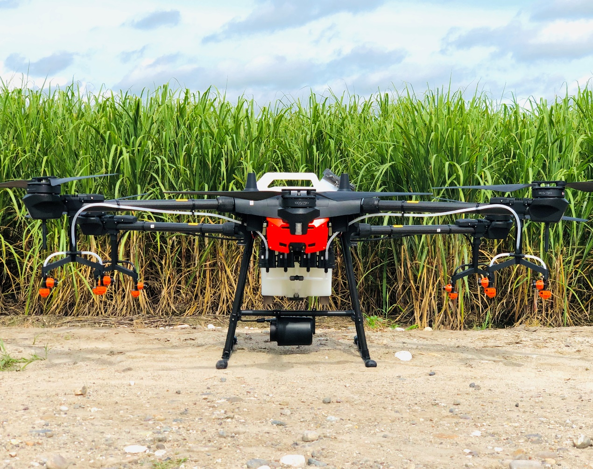
*1. Purpose of the Spray
(The purpose is to help farmers to control the insect called "Mosca Pinta" in sugar cane crops, this insect feeds on the plant causing a reduction of up to 60% sugar production.)
*2. Info of the Environment
Date of Spray | July 27, 2020 | Location | Pujiltic, Chiapas; México
Type of Terrain | flat | Temperature(℃) | 29 ℃
Total sprayed Area(ha.) | 140 ha. | Humidity | 60%
Wind speed(m/s) | 1.5 m/s | Wind direction | Unknown
The condition is favor for the spraying in sugar cane field.
*3. Operation Parameters
Type of Drone | DJI Agras T16 | Firmware Version | 02030223
Operation mode | Intellegent planing system | Operation Speed | 6 m/s
Operation height(from the top of the crop) | 3 meters | Line spacing/width | 6 meters
Liquid amount sprayed per hectare (or per MU) | 9 Liters/ha. | Nozzle type | XR11001VS
Se realizaron pruebas hasta llegar a esta conclusion, apoyado por las especificaciones de uso del producto
(Tests were conducted to reach these parameters used, supported by the product's usage specifications.)
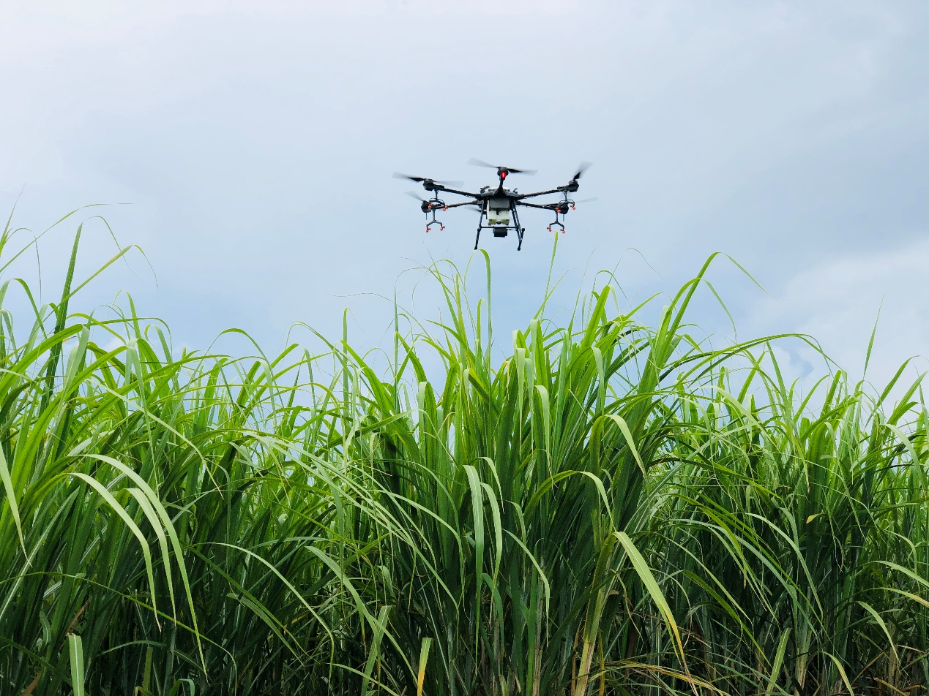
*4. Info of Chemicals (if you could)
Chemical commercial name | Formulation | Active ingredient and the percentage | Chemical amount(g or ml) used per hectare
ENGEO Syngenta  Insecticide | Suspension concentration (SC) | 141 Tiametoxam + 106 Lambdacihalotrina | 125ml in 9 Liters of water /ha
NGEO® es un insecticida foliar de amplio espectro, integrado por dos principios activos que poseen características complementarias.
El tiametoxam, es un neonicotinoide sistémico de alta residualidad, que controla insectos succionadores, mientras la lambdacialotrina es un piretroide que actúa sobre insectos succionadores y masticadores, otorgando poder de volteo. De esta manera, ENGEO® S se caracteriza por su buen poder de volteo y persistencia de contro
(NGEO® is a broad spectrum foliar insecticide, made up of two active principles that have complementary characteristics.
Thiamethoxam is a high residual systemic neonicotinoid that controls sucking insects, while lambdacialothrin is a pyrethroid that acts on sucking and chewing insects, giving tumbling power. In this way, ENGEO® S is characterized by its good turning power and persistence of control.)
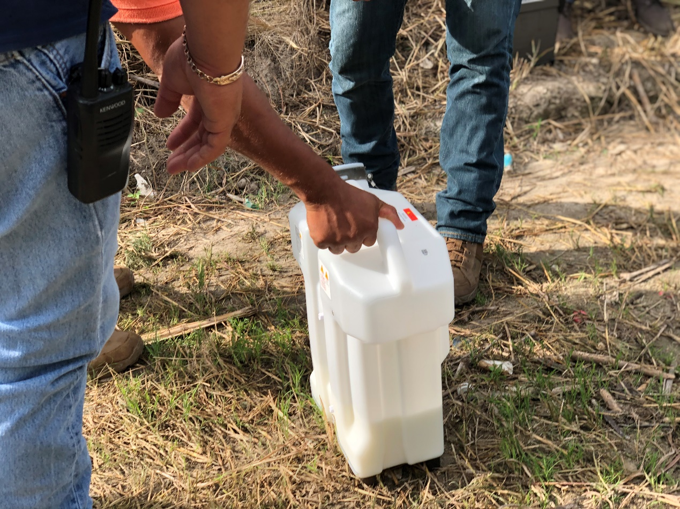
5. Briefly compare the difference between drone, manual, and other traditional equipment
in this case(cost, effect, or efficient, any advantages…). If any data comparing, it is better.
Problemática en la pulverización manual: El personal humano no puede entrar al cultivo para pulverizar con mochila debido a que el producto es muy tóxico, pone en riesgo la salud y la vida, existe poco personal humano que aceptan pulverizar solo el perímetro sin resultados eficientes y a un alto costo de mano de obra para el agricultor
(As my experience, i share the info as below:
Problems in manual spraying: Human personnel cannot enter the crop field to spray with a backpack because the crop puts human health and life at risk. There are few human personnel who accepts to do that, or spray only in the perimeter without efficient results. Besides, spraying manually contributes a high cost of labor for the farmer)
Problemática en la pulverización con helicóptero/avioneta: Las aeronaves como avionetas y helicópteros solo trabajan a partir de una cierta cantidad considerable de hectáreas, dejando fuera al pequeño agricultor, es necesaria una pista extensa o helipuerto, su pulverización no es uniforme y se necesita 200 Litros de agua, una gran cantidad
(Problems in spraying with helicopter / light aircraft: Aircraft such as light aircraft and helicopters only work from a certain considerable amount of hectares, leaving out the small farmer. And an extensive runway or heliport is necessary for them. Their spraying is not uniform and 200 Liters of water per hectare is needed.)
Problemática en la pulverización con tractor: En este tipo de cultivos de caña de azúcar no es viable la entrada de tractor
(Problems in spraying with a tractor: In this kind of sugarcane crops, the entry of a tractor is not available.)
DJI Agras T16 logró pulverizar completamente el cultivo sin invadir el suelo, rociar de forma uniforme el insecticida en toda el área en menos tiempo, sin arriesgar la vida o salud de las personas y ahorrando hasta un 90% de agua frente a otros equipos de pulverización tradicionales
(DJI Agras T16 manages to completely spray the crop without invading the soil, evenly spraying the insecticide throughout the area in a higher efficiency, without risking the life or health of people and saving up to 90% of water compared to other traditional spraying equipment. )

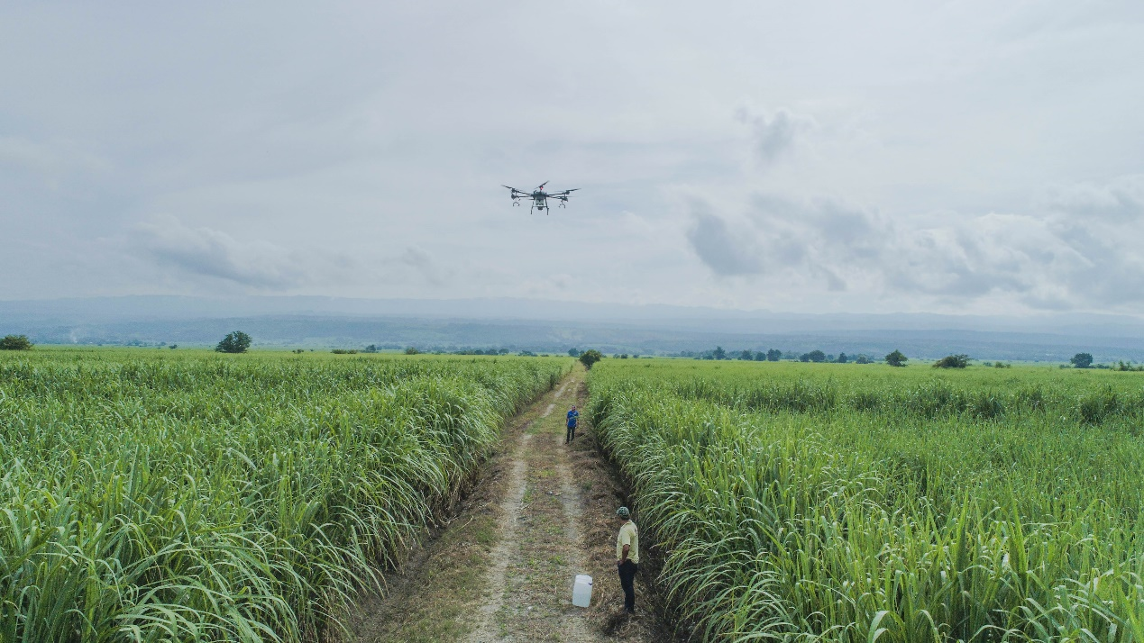
*6. Conclusion (Feel free to add any comments about spraying effect from user/farmer side, suggestions, any impressive stories, etc…)
“Cada año la mayoría de nosotros los agricultores de la caña de azúcar, solo podíamos resignarnos a la pérdida de producción de hasta 6 toneladas por hectárea debido a la falta de soluciones para combatir a la “Mosca Pinta”, esta plaga es considerada como la más peligrosa para la caña de azúcar y sin duda amenazaba el presente y el futuro nuestro sector; ahora con la implementación de drones para la pulverización DJI Agras T16, se abren nuevas oportunidades de crecimiento productivo en favor de la agricultura y la sociedad”
("Every year for most of the sugarcane farmers, they could only abandon the loss of production of up to 6 tons per hectare due to the lack of control solutions to combat the" Pinta Fly ". This pest is considered a dangerous pest for sugar cane and without a doubt threatening the present and the future of our sector; Now with the implementation of DJI Agras T16 for spraying, new opportunities for productive growth are opened in favor of agriculture and society ")

*7. Service team info
Drones Hobbytuxtla es una empresa mexicana que se especializa en la venta de soluciones con drones desde 2014, comenzamos a usar drones Agras en enero de 2019 debido a la alta demanda de servicios de pulverización, contamos un total de 1950 hectáreas hasta ahora, somos un equipo de 8 personas y tenemos experiencia en cultivos como maíz, caña, agave, etc.
Web: www.hobbytuxtla.com
(Drones Hobbytuxtla is a Mexican company that specializes in the sale of solutions with drones since 2014. We started using Agras drones in January 2019 due to the high demand for spraying services, with spraying a total of 1950 hectares so far. We are a team of 8 people with experience in crops such as corn, sugarcane, agave, etc.
Web: www.hobbytuxtla.com)

Contact person：Roberto Robles
Contact info（phone or email）Email: info@hobbytuxtla.com
*8. Link of pics or videos, or attach them in the email（of field landscape, preparing work, chemical bottles, Agras which is spraying, spraying effect on water sensitive paper or dead pests, etc.）: https://we.tl/t-dhfLg6ctm8

Warm prompt: the content and parameters provided here are just for reference. You should adjust the operation mode and the parameters and use a correct way to spray your field according to the different weather, the crop characters, the habit or history of using chemicals(you could change other chemicals in case that the resistance occurs), etc. If you are not sure what operation parameters you will choose or not sure about the spraying efficacy, then you should firstly do a small plot test in this field before a big area spray.

