DJI Agras MG-1S sprayed Sugar Cane in South Africa
Sugarcane is the 3rd largest full cover food crop in South Africa by area – currently covering around 380,000 hectares and mostly farmed in the KwaZulu-Natal and Mpumalanga provinces. The height and density of sugarcane makes it difficult for labour and tractors to apply the necessary pesticides, therefore the industry relies very heavily on the aerial (aircraft) application of pesticides. Sugarcane in South Africa is mostly grown on hillsides which often makes even traditional aircraft (fixed wing, helicopter and microlight) applications very difficult and imprecise. The DJI Agras spray drones are far more capable of delivering effective precision applications than the traditional aircraft in the technical terrain conditions mostly found in the South African sugarcane industry. The more precise and effective the application, the more revenue realised by the farmer.
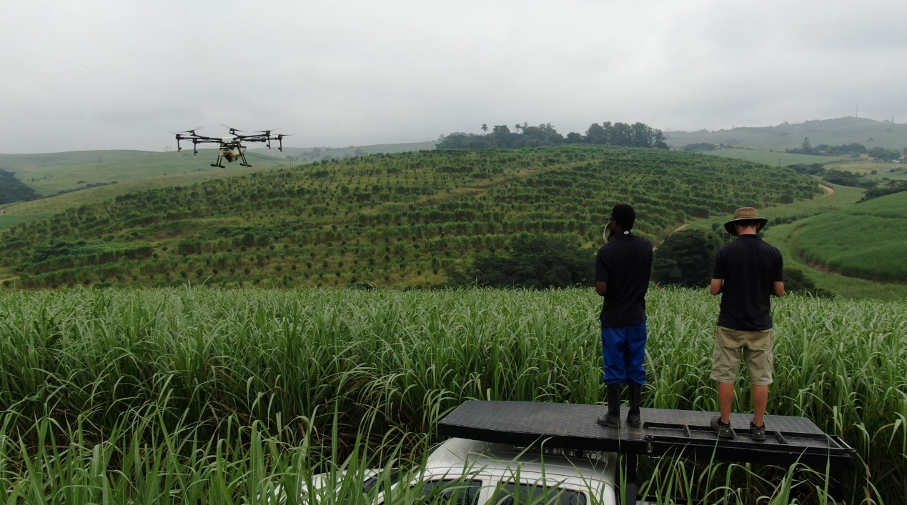
*1. Purpose of the Spray (please introduce the specific crops and plant disease):
Sugar Cane ripening application. This application is done approximately 8 weeks prior to harvest to enhance sugar production in the plant. Enhanced sugar production means greater profits for the farmer.

*2. Info of the Environment
Date of Spray | 03/06/2020 | Location | Umhlali, KZN, South Africa
Type of Terrain | Uneven hillsides | Temperature(℃) | 21℃
Total sprayed Area(ha.) | 8.4Ha | Humidity | 54.8%
Wind speed(m/s) | 0 | Wind direction | (N/A)

*3. Operation Parameters
Type of Drone | MG-1S | Firmware Version | 4.1.1.0
Operation mode | Intelligent planning system | Operation Speed | 5.3m/s
Operation height(from the top of the crop) | 2m | Line spacing/width | 3.5m
Liquid amount sprayed per hectare (or per MU) | 20L/Ha | Nozzle type | XR110015VS
Sugar cane leaves are not very dense over the top, so the drone is actually about 2 meters above the top of the leaves and the effective spray width we’ve found is 3.5m. 20L/ha is a bit lower but still acceptable.

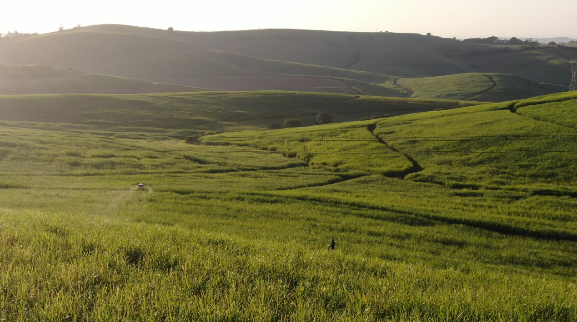

*4. Info of Chemicals (if you could)
Chemical name: | Formulation: | Active ingredient and the percentage: | Chemical amount(g/ml) used per ha:
Orca 125 | EC | Fluazifop-p-butyl 125 g/l (12.5%) | 330ml/Ha
The active ingredient of Orca 125 is Fluazifop-p-butyl (aryloxyphenoxypropionate) . Orca 125 is a selective, systemic emulsifiable concentrate herbicide that is applied as a post-emergent spray for the control of annual and perennial grasses in crops as indicated; for the chemical ripening and eradication of sugarcane and also for the sup-pression of seeding and grass growth on verges.

5. Briefly compare the difference between drone, manual, and other traditional equipment in this case.

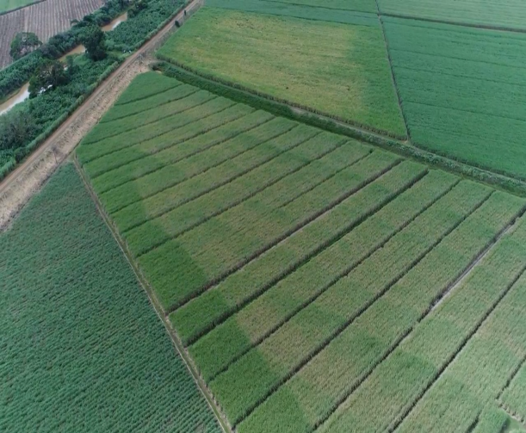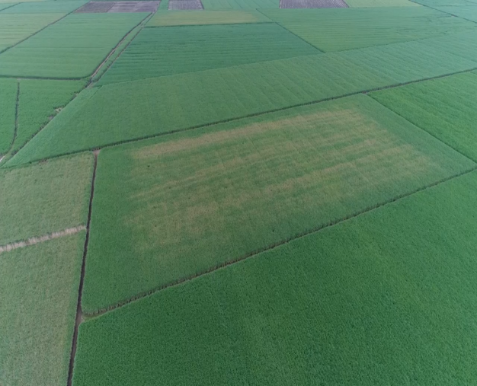
Bad Quality Spraying from Traditional Aircraft (airplane, helicopter, microlight)
The green parts/stripes are areas that the aircraft have not sprayed with the chemical. The missed green areas mean the farmer will make less money from the crop in these areas. Sometimes these “missed” areas are about 50%-75% of the crop area so it’s a lot of money the farmers are missing out on. It also shows uneven application in the middle of the field because the aircraft is not on auto-pilot and doesn’t use GPS controlled spraying lines. It’s susceptible to human error.

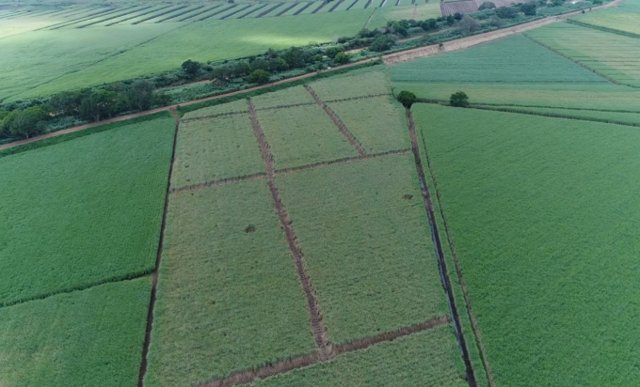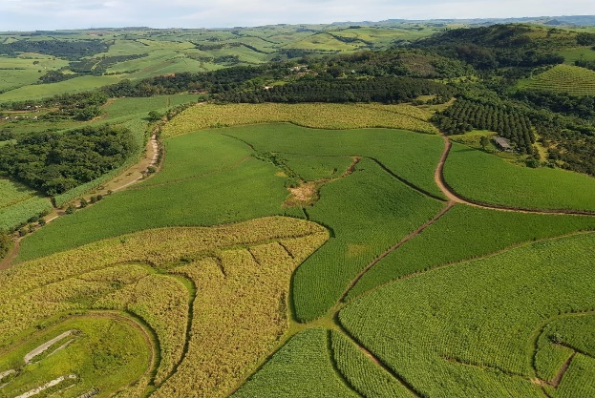
Superior Quality Spraying with Drones (MG-1S / MG-1P / T16)
These pictures show how precise the drones are compared with the aircraft. The drone achieves full coverage of the field and with very even coverage inside the field as well. It is hard for the aircraft to spray these technical hillside fields with the same accuracy, precision and even coverage as the drones.
The quality of drone application is far superior to traditional aircraft (fixed wing plane, helicopter and microlight) application. The DJI Agras is capable of more precise, full cover / even applications in difficult terrain. For this particular sugar cane ripening application – the drone ultimately generates more profits for the farmer than the large aircraft.

*6. Conclusion
As per the above – it is proven that the farmers make more money from precise drone sugar cane ripening spraying applications than they do from the larger traditional aircraft.

*7. Service team info

Your company or team name: PACSys

PACSys has been DJI’s African official distributor since 2017. We have tested DJI Agras in all African crops and sugar cane has been the most successful crops with the drones because the sugar cane farms and fields in South Africa are typically smaller and on steep hillsides which makes it difficult for the larger traditional aircraft to spray. These farms require smaller precision application methods – exactly like the drones are capable of. PACSys started because the farmers came to us asking for solving the problem of bad quality applications from the traditional aircraft on their farms. 3 Years later our drones have sprayed approximately 150,000 hectares of mostly sugar cane and PACSys is now the drone spraying market leader in Africa. The T16/T20 will open many more markets than sugar cane now. Please see our video link below:
https://www.youtube.com/watch?v=0SNTEeOXU8o
Contact person：Timothy Wise
Contact info (phone or email):+27 76 550 7692 / tim@pacsys.co.za

Warm prompt: the content and parameters provided here are just for reference. You should adjust the operation mode and the parameters and use a correct way to spray your field according to the different weather, the crop characters, the habit or history of using chemicals(you could change other chemicals in case that the resistance occurs), etc. If you are not sure what operation parameters you will choose or not sure about the spraying efficacy, then you should firstly do a small plot test in this field before a big area spray.

