**Spraying Vines in Switzerland Using DJI Agras**

Switzerland contains a total vines area of 14712 ha. The annual turnover of the grape growers in Switzerland is approximately CHF 550 million.

For the optimisation of the grape harvest, viners treat the plants with pesticides, multiple times per season. Traditionally, this work is mostly performed manually or with specialized machines, which is physically very demanding on the one hand and can be time-consuming on the other. 8-10 treatments are applied, which gives a rhythm of about 10 days for the repetitive spraying with pesticides. A mildew attack does not only destroy the actual harvest in the worst case, it even has negative effects for the following years.

On very steep slopes, there is a big risk of accidents with the vehicles, as these can overturn. Numerous deaths from the past years testify to this.

For the winegrowers, treating the vines from the air with an agricultural drone brings clear operational advantages. Some winegrowers have already had some experience with this and there is a certain acceptance of the new technology.

**\*1. Purpose of the Spray**

Crops: vines (seedlings, young plants, grown up plants)

Diseases: powdery mildew, Downy mildew, other fungal diseases

**\*2. Info of the Environment**

|  |  |  |  |
| --- | --- | --- | --- |
| Date of Spray | 2020.6.2-3  2020.6.8  2020.6.16, Repeat every week | Location | Hallau, Switzerland |
| Type of Terrain | Flat & Steep | Temperature(℃) | 15 – 25°C |
| Total sprayed Area(ha.) | 3.5 ha. of young plants 4 ha. of adult plants | Humidity | different |

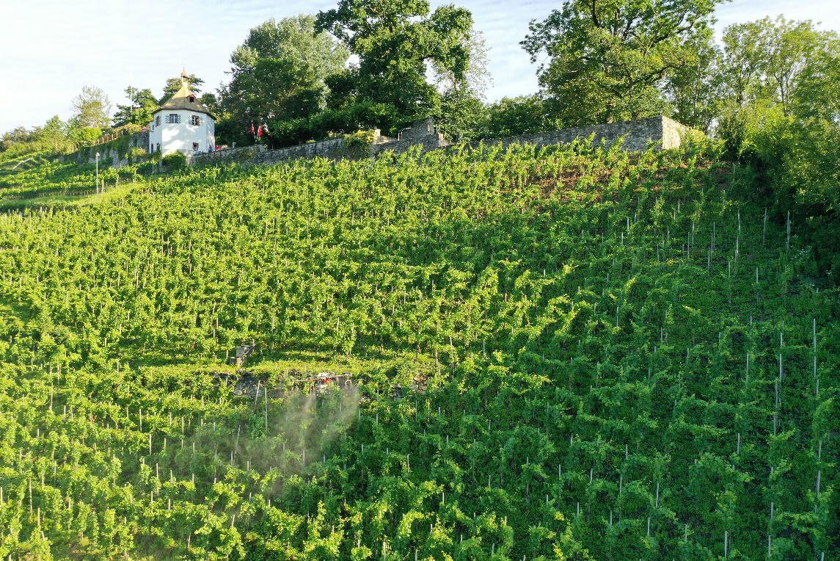

**\*3. Operation Parameters**

|  |  |  |  |
| --- | --- | --- | --- |
| Type of Drone | MG-1P & T16 | Firmware Version | T16: V02.01.0312  MG-1P: V02.01.0012 |
| Operation mode | Intelligent route planning | Operation Speed | T16: ~3m/s  MG-1P: ~1.5m/s |
| Operation height(from the top of the crop) | 3m | Line spacing/width | 3m/4m(according to the planning line width) |
| Liquid amount sprayed per hectare | 100 l / ha | Nozzle type | XR110015VS |

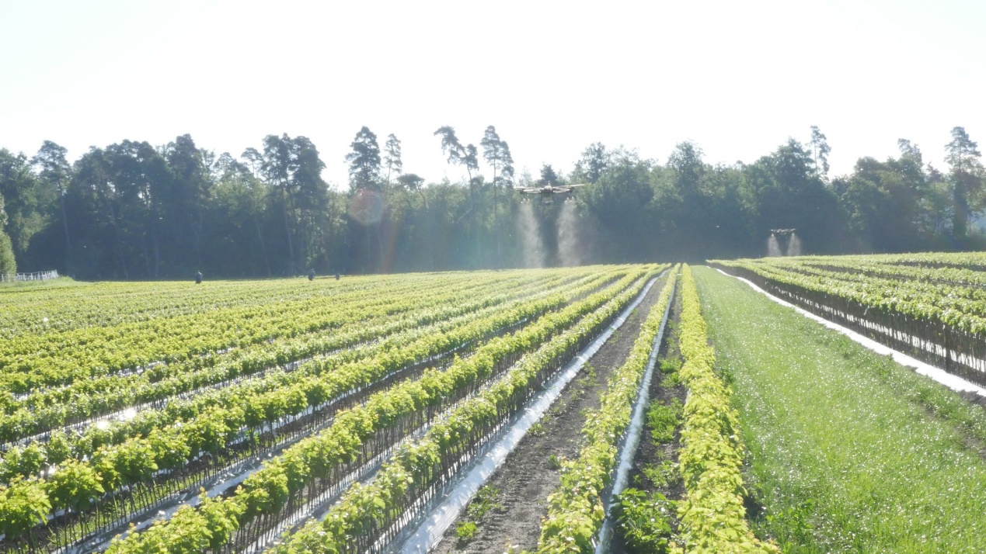

**\*4. Info of Chemicals**

|  |  |  |  |
| --- | --- | --- | --- |
| Chemical commercial name | Formulation | Active ingredient and the percentage | Chemical amount(g/ml) used per hectare |
| Folpet | WG | Folpet 80% | 1.2kg/ha |
| Booster | SC | Kaliumphosphonat 51.7% | 1 L/ha |
| Celos | WG | Schwefel 80% | 2.4 kg/ha |

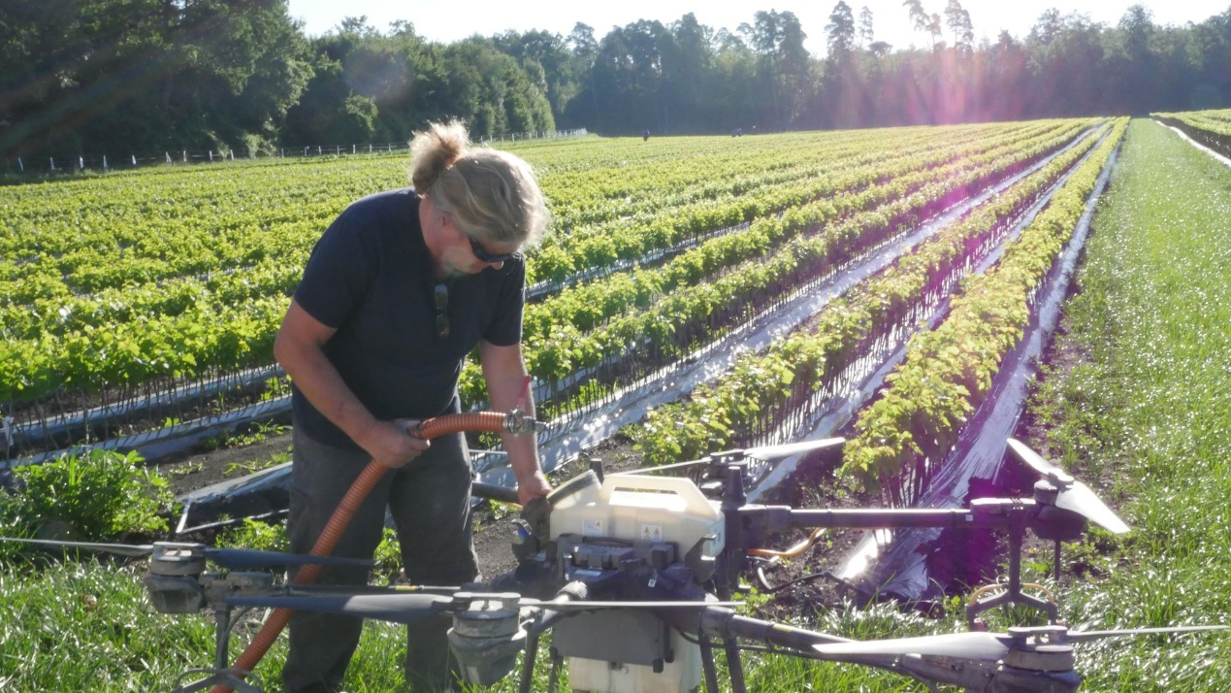

*6. Conclusion

A lot of vines are sprayed in Switzerland with drones. This client is special because we spray young plants for him, which are especially sensitive and valuable. Manual spraying is done with tractor, but they have lots of problems in steep hills.

The drone spraying application is very dense monitored by the customer who is a country widely-known specialist for young vines. He built up special landing platforms for the spraying drone.

Spraying in vines is mostly for preventing against the disease happening.



Downey mildew happens if no spraying.

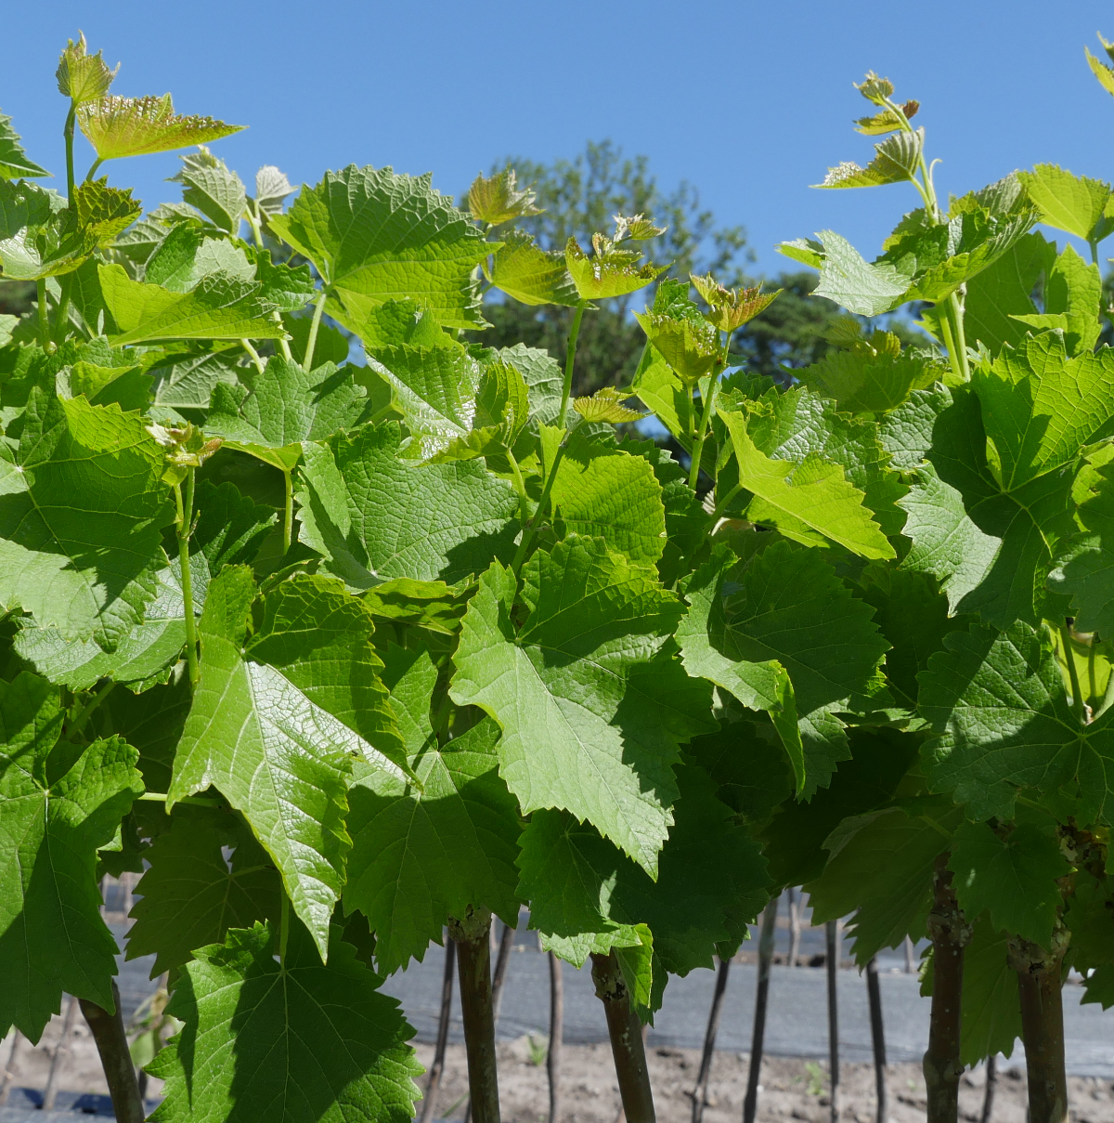

Healthy plants after spraying

.

The client actively compares drone spraying with earlier tractor spraying. The client is happy with drone spraying, reasons:

* No personal contact to pesticides
* Same speed in flat terrain as tractor, however, in steep terrain the DJI Agras has a much higher efficiency.
* No [phytotoxicity](javascript:;) happens.

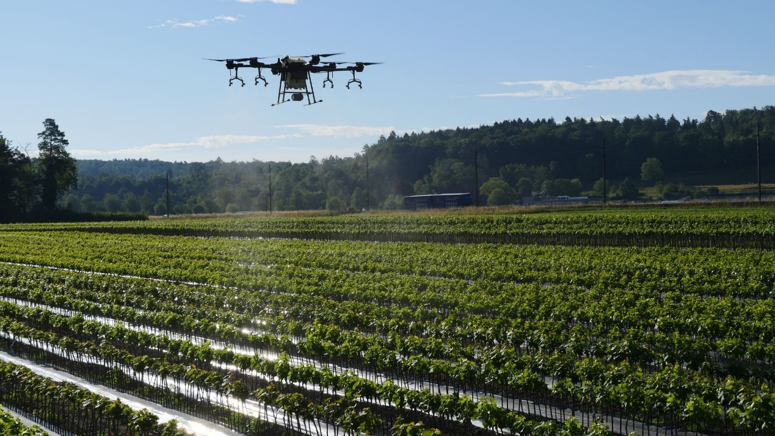

**\*7. Service team info**

Our company name is Remote Vision. And we started spraying since 2016 for vines, crops, vegetables, and more. We actually have 3 spraying teams.

Contact person：Ueli Sager

Contact info（phone or email）ueli.sager@remotevision.ch

**Warm prompt:** the content and parameters provided here are just for reference. You should adjust the operation mode and the parameters and use a correct way to spray your field according to the different weather, the crop characters, the habit or history of using chemicals(you could change other chemicals in case that the resistance occurs), etc. If you are not sure what operation parameters you will choose or not sure about the spraying efficacy, then you should firstly do a small plot test in this field before a big area spray.