Case Study | MG-1S Enables Efficient Spraying for Eucalyptus
Eucalyptus is one of the fastest-growing trees in the entire world and remains lush and green throughout the year. Capable of natural regeneration from sprouts and improving marshland conditions, it is widely used in many regions of the world.
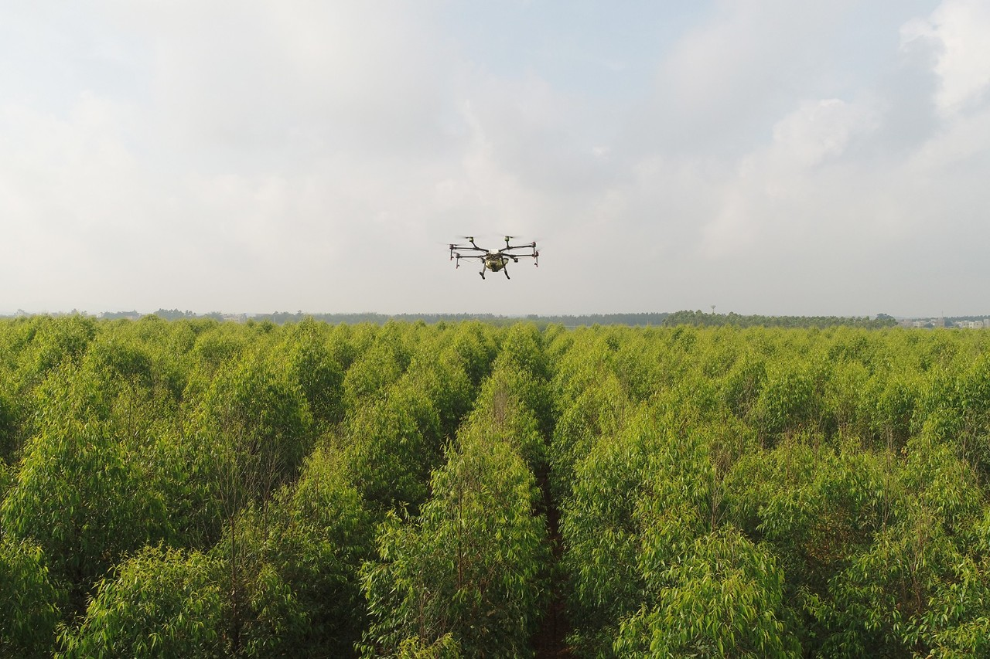
Eucalyptus is usually attacked by a variety of insects, including white ants, grubs, mole crickets, cutworms at the roots, Buzura suppressaria Guenee and eucalyptipsyche citriodorae on the leaves, crickets, grasshoppers at the tips, woodworms and bark beetles at the trunks, and more. In the past, pest control was mainly realized through traditional air duct operations as eucalyptus is normally planted on the mountains where manual spraying has a number of disadvantages including access, low efficiency, and waste. Eucalyptus is also quite tall, so pesticides are typically sprayed upwards, which means workers responsible for the spraying will be exposed to hazardous pesticides that can be harmful to their health.

In order to strengthen the pest control for Eucalyptus and achieve the goal of rapid production increase, Zhanjiang Shuoke Agriculture Technology Co., Ltd. applied the MG series agricultural drones to spray 329.5 acres.

1.
Team Introduction

Zhanjiang Shuoke Agriculture Technology Co., Ltd. has 20 professional drone pilots. It also has UAV plant protection teams in Zhanjiang, Leizhou, Hainan, Suzhou, and Sinkiang. Since being founded, it has provided UAV services for roughly 33,000 acres of land. The main plants that it has protected include rice, corn, banana, wheat, cotton, eucalyptus, mango, lychee, betel nut, and more.

2.
Environment Information
Operation Dates | May 2-5, 2018 | Location | Suixi, Zhanjiang
Land Type | Plain | Conditions | No no-fly zone, closely grouped land

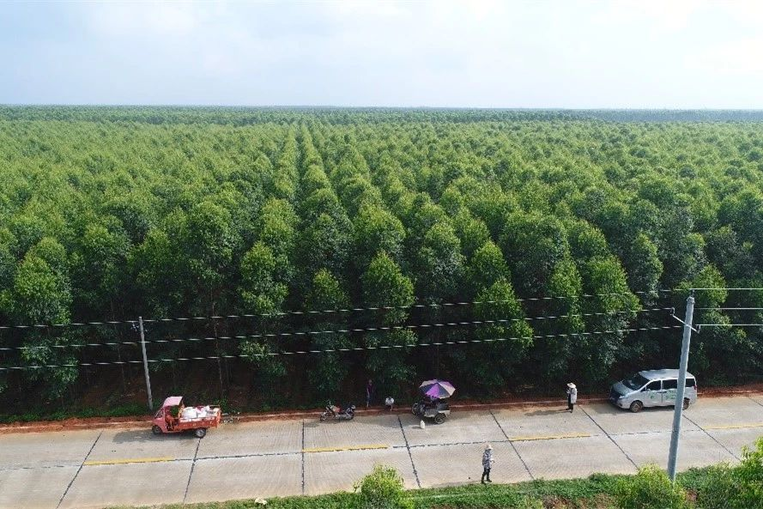
3.
Operation Parameters
Flight Mode | Flight Route Planning | Flight Speed | 4 m/s
Flight Altitude | 2-2.25 m | Route Spacing | 4 m
Amount Per Acre | 10.8 L | Nozzle Type | XR11001VS

We used flight route planning for the dense eucalyptus area. With two MG-1S units, we can spray about 50 acres per day. It is recommended to avoid spraying operations during midday, or on rainy days; otherwise, the spraying effects will be diminished.
4.
Pesticide Information
Pesticide Name | Type | Concentration of Active Ingredient | Amount per acre
Abamectin | Emulsifiable Concentrate | 5% abamectin | 360 ml
Beta-cypermethrin | Emulsifiable Concentrate | 4.5% beta-cypermethrin | 390 ml

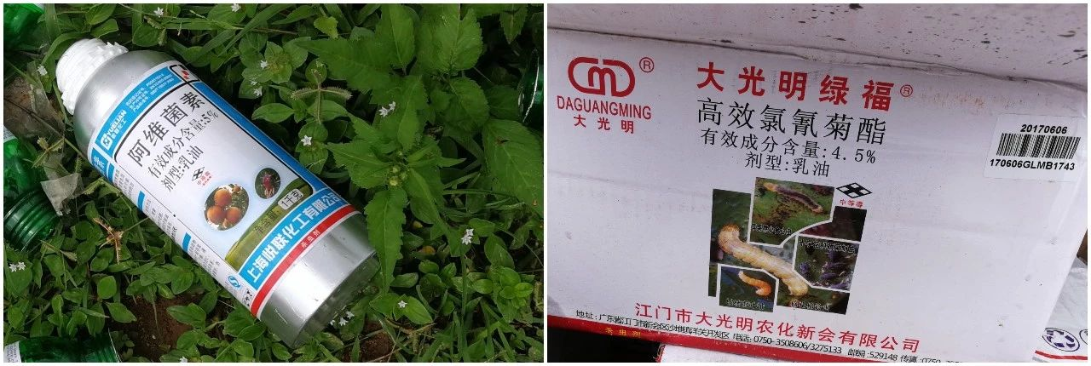
The pesticide used in this operation was made using two types and featured broad-spectrum insect killing effects. The amount of pesticide used during this operation is relatively high due to the serious prevalence of insect damage. It is recommended that users select appropriate pesticide(s) and amounts according to observable conditions.
5.
Spraying Effect
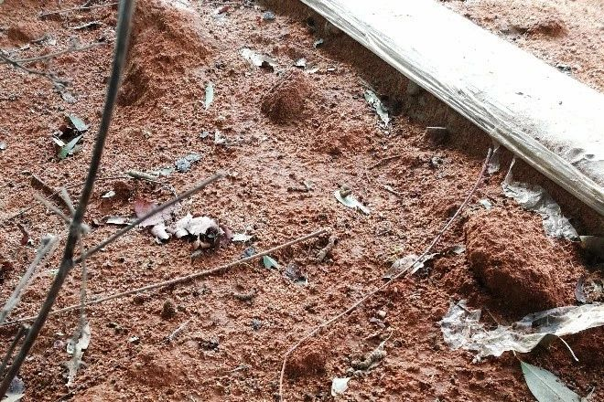
A large number of insects and pests died within one hour of spraying.
6.
Conclusion

Eucalyptus can be up to 16 meters tall, so it is important to pay special attention while selecting the takeoff point and the position of the pilot. Since the area’s overall height was relatively uniform, and obstacle-obtaining radar was not available during this operation, our pilots took extra care to pay attention to the process to ensure spraying efficiency and safe operation.
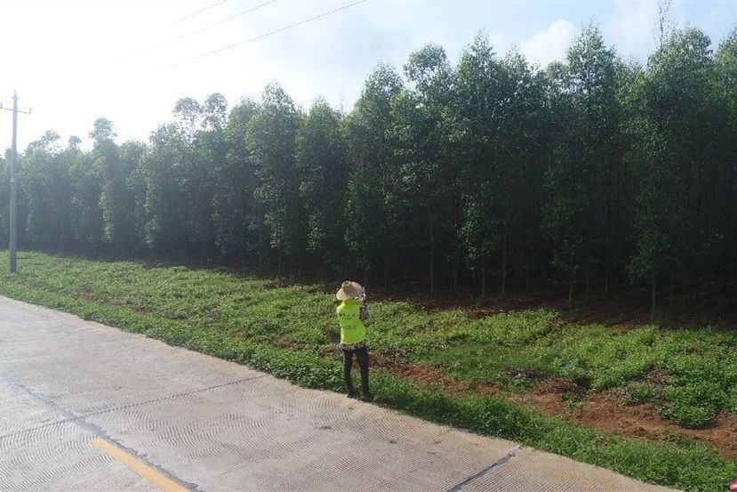
Users have tried plant protection drones from other brands before. However, due to uneven, overlapping, and inefficient spraying, the insect problems were not solved effectively. After cooperating with DJI, users were very satisfied as we used Flight Route Planning together with manual spraying route planning to avoid redundancies and inefficient spraying. The growers also expect to adopt our solutions for subsequent UAV spraying operations.

