DJI Agras T16 sprayed Maize in Serbia
Maize is the most common crop in Serbia. About 1 million hectares are sown annually and the average yield is approx. 6.5 tons per hectare while top-tier growers easily produce more than 10 t/ha. Most remain in domestic market; still significant volume is exported. In order to achieve the highest possible yields, full spectrum of agrotechnical measures is necessary. Fighting pests that attack in late stages of growth was dependent on heavy expensive machinery that hardly could reach the fields and not possible without partial damage to crops until the advent of drones.
*1. Purpose of the Spray
Treatment was a part of recommended technology in maize production. Purpose was protection from Corn borer (Ostrinia nubilalis) as well as application of foliar fertilizer.
*2. Info of the Environment
Date of Spray | August 4th 2020 | Location | Adrojan-Kanjiza,  Vojvodina region Serbia
Type of Terrain | Flat land | Temperature(℃) | 20-24
Total sprayed Area(ha.) | 23 | Humidity | 65%
Wind speed(m/s) | 1,5-5 m/s | Wind direction | SW
Attention to the wind intensity was necessary, as spraying above Beaufort level 2 can lead to uneven spraying deposit and contamination of neighboring plots.
*3. Operation Parameters
Type of Drone | DJI Agras T16 | Firmware Version | V02.01.0312
Operation mode | Intelligent route planning | Operation Speed | 4.7 m/s
Operation height(from the top of the crop) | 2 m | Line spacing/width | 6m
Liquid amount sprayed per hectare (or per MU) | 20 lit/ha | Nozzle type | XR11001VS
We used standard height and spacing and speed parameters to achieve maximum efficiency and cover the entire corn tree with treatment. Slightly larger liquid volume per hectare was chosen due to combination of chemicals.
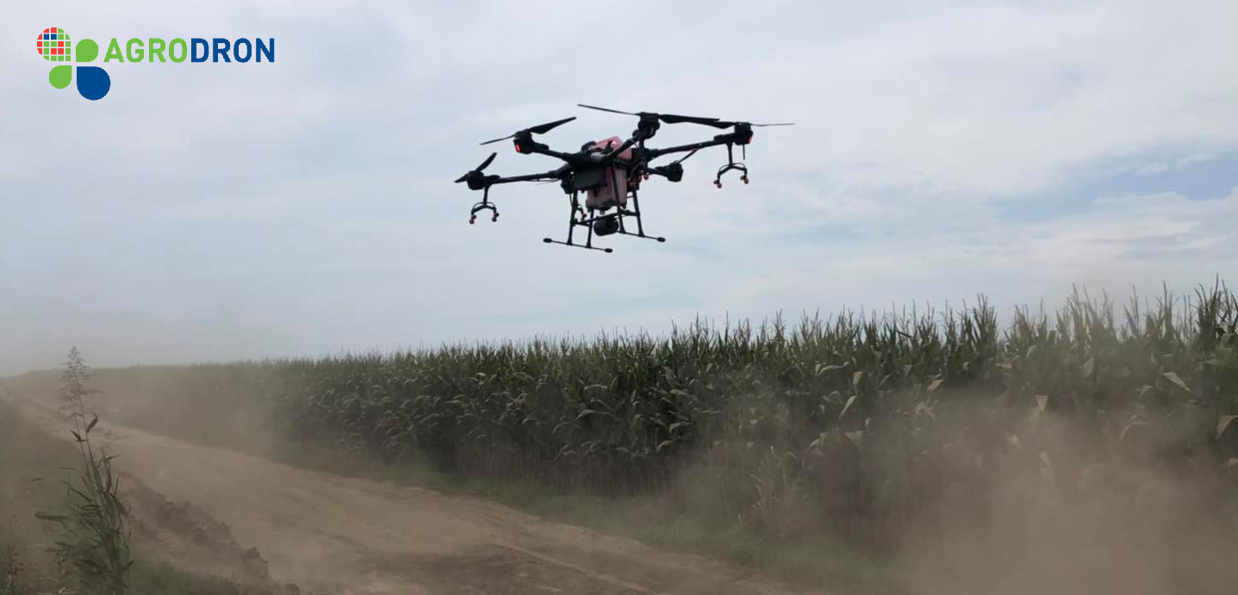

*4. Info of Chemicals
Chemical commercial name | Formulation | Active ingredient and the percentage | Chemical amount(g/ml) used per hectare
Coragen 20 SC | SG | Rynaxypir | 0.15 l/ha
Basfoliar 36 Extra | SL | Foliar fertilizer 27% N | 3 l/ha
Trend 90 | SL | Adjuvant | 0.015 l/ha
Based on the research and the testing only two pesticides are adequate for Corn borer treatment. Both of them are based on Rynaxypir (Chlorantraniliprole). Coragen 20 SC is single active ingredient safe for bees and predatory insects so it was logical to choose it for the treatment.
5. Briefly compare the difference between drone, manual, and other traditional equipment in this case.
Height of maize in the moment of application was cca 1.1-1.2 m so as an alternative to treatment with high clearance sprayer treatment with DJI Agras T16 was done. Main advantage was drone application provided treatment in the exact moment when it was needed, due to the fact that common mechanization was not able to do the treatment because of soil moisture (saturated after extensive precipitation).
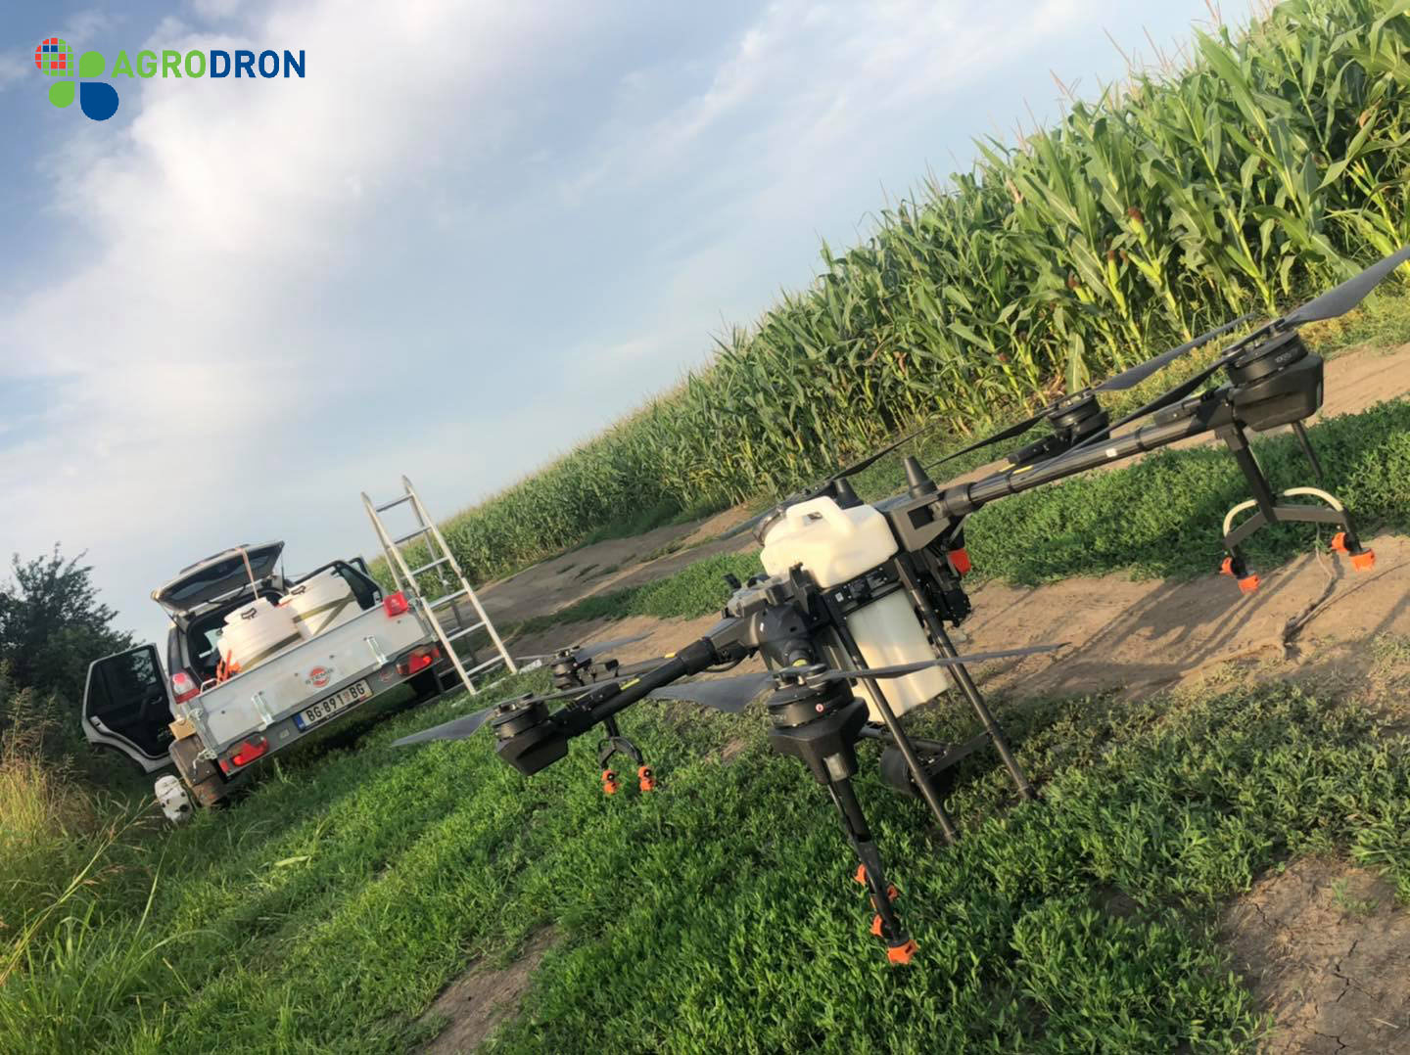

*6. Conclusion
Treatment was efficiently done. Crop was protected from pests and application of foliar fertilizer was done too.
*7. Service team info
The AGRODRON team is the first company in Serbia and the region to deliver professional UAS spraying technology and its regular application in the protection of agricultural crops using own fleet of DJI Agras T16 aircraft. Team gathers experienced drone operators, agronomist, mechatronics, sensing and data specialist and trainers. In our work so far, we have been very successful in treating all types of crops that are represented in region, all with the aim of promoting new technology and the benefits it brings.
Contact persons: Momir Alvirović, Goran Iskić, Zoran Stojanović.
Contact info: info@agrodron.rs
Warm prompt: the content and parameters provided here are just for reference. You should adjust the operation mode and the parameters and use a correct way to spray your field according to the different weather, the crop characters, the habit or history of using chemicals(you could change other chemicals in case that the resistance occurs), etc. If you are not sure what operation parameters you will choose or not sure about the spraying efficacy, then you should firstly do a small plot test in this field before a big area spray.

