DJI Agras T16 sprayed Maize in Serbia
Maize is the most common crop in Serbia and many base seed production and breed selection companies work on producing quality seeds for the region. About 1 million hectares are sown annually and the average yield is approx. 6.5 tons per hectare, while top-tier growers produce more than 10t/ha. Most remain in domestic market; still significant volume is exported. In order to achieve the highest possible yields, full spectrum of agro technical measures is necessary. Fighting pests that attack in late stages of growth was dependent on heavy expensive machinery that hardly could reach the fields and not possible without partial damage to crops until the advent of drones.
*1. Purpose of the Spray
Treatment was a part of recommended technology in selection of maize seed lines and base seed production for the Maize institute Zemun Polje, Serbia. In the same period, we have delivered same treatment to test production crops of Corteva/Pioneer, KWS, AgriReserach in our region. Purpose was protection from Corn borer (Ostrinia nubilalis). Two treatments were done. First one in the first decade of July, and another one at the beginning of August, targeting two different generations of Corn borer.
Characteristic of these treatments in institute environment was that they were performed on large number of small plots, from 0.4 to 6 ha each.
*2. Info of the Environment
Date of Spray | July 7th 2020 | Location | Zemun polje,  Srem region, Serbia
Type of Terrain | Flat land | Temperature(℃) | 20-28
Total sprayed Area(ha.) | 23 ha in 19 plots | Humidity | 65-55%
Wind speed(m/s) | 1,5-4 m/s | Wind direction | W

Date of Spray | August 6th 2020 | Location | Zemun polje,  Srem region, Serbia
Type of Terrain | Flat land | Temperature(℃) | 20-29
Total sprayed Area(ha.) | 23.2 ha in 18 plots | Humidity | 50-55%
Wind speed(m/s) | 1,5-3 m/s | Wind direction | SE
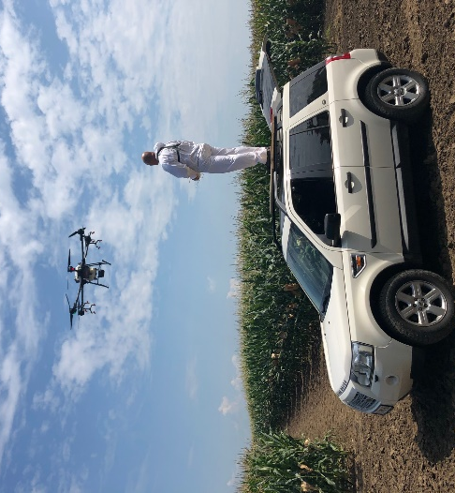
Drone based spraying efficiency can drop significantly in higher temperature due to mid-air evaporation of small droplets, as well as chemical efficiency that can drop with temperature as well, so we chose to work in the morning while below 30C.
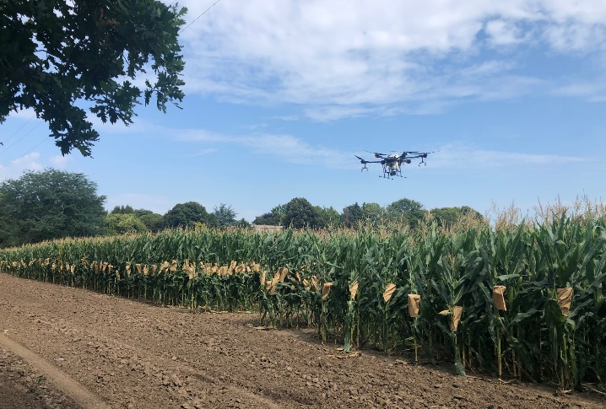

*3. Operation Parameters
3. Parameters
Type of Drone | DJI Agras T16 | Firmware Version | v02.01.0312
Operation mode | Intelligent route planning, A-B route | Operation Speed | 4.7 m/s
Operation height(from the top of the crop) | 2,2 m | Line spacing/width | 6m
Liquid amount sprayed per hectare (or per MU) | 15 lit/ha | Nozzle type | XR11001VS
We have used standard flight parameters in order to achieve maximum efficiency and cover the entire corn tree with the treatment.
*4. Info of Chemicals
Chemical commercial name | Formulation | Active ingredient and the percentage | Chemical amount(g/ml) used per hectare
Coragen 20 SC | SG | Rynaxypir | 0.15 l/ha
Trend 90 | SL | Adjuvant | 0.015 l/ha
Based on the research and the testing, only two pesticides are adequate for Corn borer treatment. Both of them are based on Rynaxypir (Chlorantraniliprole). Coragen 20 SC is single active ingredient safe for bees and predatory insects so it was logical to choose it for the treatment.
5. Briefly compare the difference between drone, manual, and other traditional equipment in this case.
Height of the maize in the moment of first treatment was approx. 1.10-1.20m, and in second treatment it was over 2.50 m so as an alternative to treatment with high clearance sprayer treatment with DJI Agras T16 was done. Main advantage was that drone application provided treatment that is efficient and with no damage to the crops. Significant advantage of drone-based spraying was much shorter reaction time (from conditions met and order placed to the delivery of the treatment) and easier machinery manipulation due to the fact that treated plots are small and therefore it is hard to manipulate mechanization in it. Using classical mechanization, even when treatments are performed with care, makes damage to the crops. Selection line production and base seed production is very expensive and the fact that drone application makes no damage to the crop is one great advantage.

*6. Conclusion
Treatment was efficiently done and provided crop was protected from pests. No damage on the crops was observed. Main recommendation is to take care about temperatures to avoid pesticide premature evaporation or enslavement of treatment solution in inversion layer of air.
*7. Service team info
The AGRODRON team is the first company in Serbia and the region to deliver professional UAS spraying technology and its regular application in the protection of agricultural crops using own fleet of DJI Agras T16 aircraft. Team gathers experienced drone operators, agronomist, mechatronics, sensing and data specialist and trainers. In our work so far, we have been very successful in treating all types of crops that are represented in region, all with the aim of promoting new technology and the benefits it brings.
Contact persons: Momir Alvirović, Goran Iskić, Zoran Stojanović.
Contact info: info@agrodron.rs
*8. Link of pics or videos:
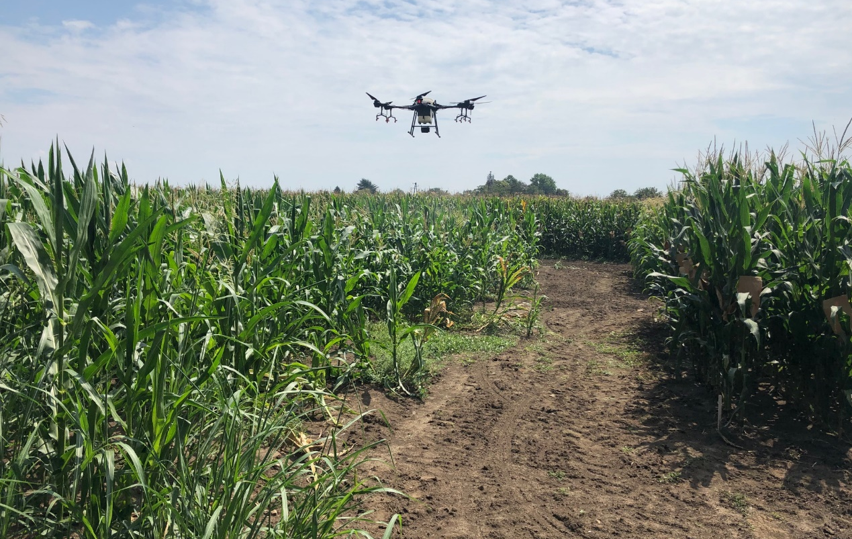

Warm prompt: the content and parameters provided here are just for reference. You should adjust the operation mode and the parameters and use a correct way to spray your field according to the different weather, the crop characters, the habit or history of using chemicals(you could change other chemicals in case that the resistance occurs), etc. If you are not sure what operation parameters you will choose or not sure about the spraying efficacy, then you should firstly do a small plot test in this field before a big area spray.

