Case Study: Controlling Corn Borers in Xinjiang Province

At the end of June 2017, Bole City, located in Xinjiang, China suffered an outbreak of corn borers. In order to control the outbreak, the Xi’an based Tianyi Aviation Technology Co., Ltd. sent out an agriculture service team that traveled 3,100 kilometers to conduct aerial spraying for affected cornfields covering 2,735 acres.
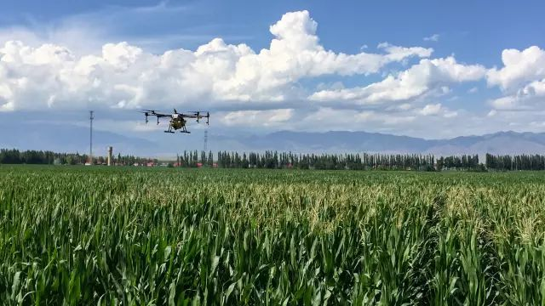
DJI MG-1S during operation

Upon arrival, the team assessed the situation and found that roughly 50-55% of the corn had been affected. Borers had severely damaged the young cobs and leaves of the corn, and the situation was deteriorating.
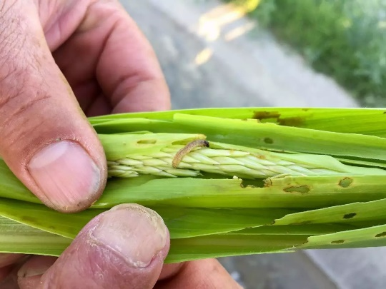

「Spraying Condition」

The weather was ideal for aerial spraying, with calm winds and mild temperatures. The team decided to start its operation on June 25.

Operation Time | 25/6/2017-13/7/2017 | Location | Bole City, Xinjiang Province, China
Terrain | Dry lands | Environment & Weather | Sunny (16°-26°C)  Level 2 winds

「Dosage」

The team decided to use multiple pesticides to achieve optimal results. Detailed information is as follows:

Pesticide | Dosage Form | Effective Component and Concentration | Dosage (per acre)
Beta-cyfluthrin | Suspending agent | 10% | 40.24 ml
Chlorpyrifos | Emulsifiable Concentrate (EC) | 45% | 610 g
Profenofos & Phoxim | EC | Total: 40  Phoxim: 34%  Profenofos: 6% | 121 ml

「Operation Parameters」

Operation Mode | Intelligent Operation Mode | Flight Speed | 4.5-5 m/s
Flight Altitude | 2.5 m | Working Interval | 5 m
Dosage (liters per acre) | 1 | Nozzle Type | Fan shape XR11001

「Pest Control Effect」

Random sampling before spraying showed that, on average, there were 30 borers per 50 plants. That figure dropped to 6 borers per 50 plants after spraying, meaning the borers' mortality rate was about 80%.
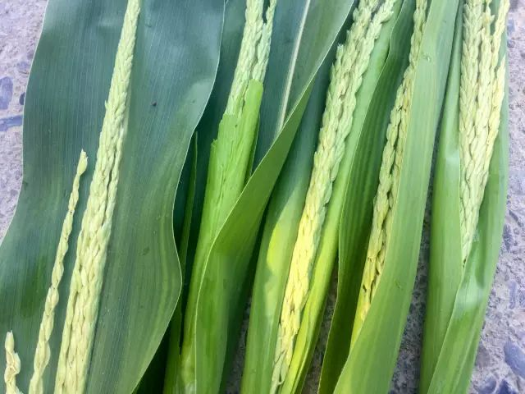

「Result」
The spraying proved to be highly effective in controlling pest infections.

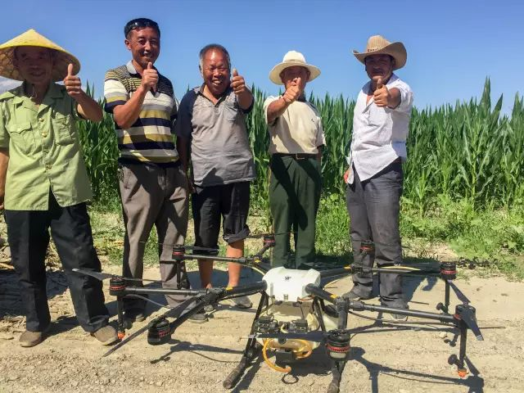

Contact:
Xi’an Tianyi Aviation Technology Co., Ltd.
Zhang Shiwei: 181-8913-0399
Wang Ke: 136-1921-8757

