The Agras T16: An Appealing Solution for Banana Pest Control

DJI agricultural drones have been widely recognized in pest and disease control for rice, wheat, cotton, peanut, and other field crops. With the release of the Agras T16, what can this new drone do for controlling pests in fruit trees?
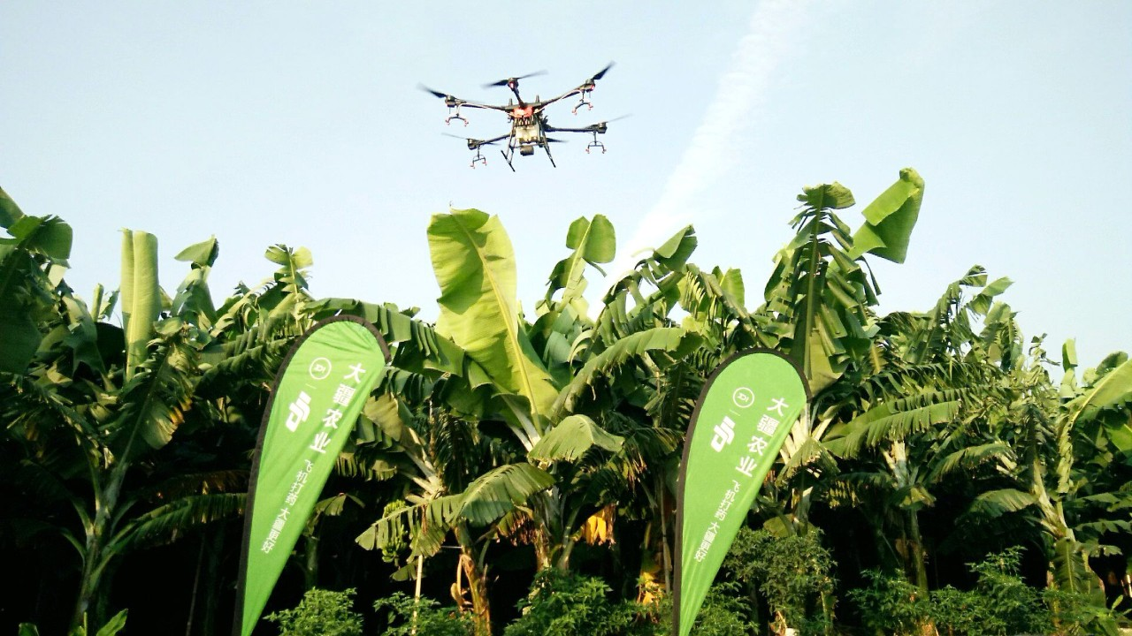

On March 28, 2019, a spraying team in Hainan, China used two T16 drones to tackle the spread of thrip and the black Sigatoka leaf spot throughout 16 hectares of banana trees in Dongfang City.

“For fruit trees such as bananas, the spraying flow and droplet sedimentation of the T16 meet control requirements, as well as greatly improve the efficiency of operation,” Said Yang, an operational pilot on the scene.

The successful operation ran through March 2017, using the parameters listed below:

Environment Information

Land Type | Flat | Location | Basuo County, Donfang, Hainan
Wind | Lv. 3 | Temperature & Weather | Sunny,  23°C-30°C

Operation Parameters

Flight Mode | Route Operation | Flight Speed | 4.5 m/s
Flight Altitude | 2.5 m | Route Spacing | 5.5 m
Volume per Hectare | 174.2 ml | Nozzle Type | XR110015VS

The banana trees were rooted in a flat terrain with regular land parcels, which is suitable for Route Operation mode (fully automatic). Since banana trees are tall and have multiple canopy layers, the team flew the T16 slowly to ensure adequate coverage of the sprayed solution. To guarantee the spraying effect and maximize the work efficiency, the team set the dosage per hectare to 174 ml and the flight speed to 4.5 m/s.

Pesticide and Fungicide Information

Pesticide/Fungicide Name | Type | Concentration of Active Ingredient | Amount per Hectare
Taosiben | Emulsifiable Concentrate | 45% Dursban | 1.34 ml
Zhengmeng | Microemulsion | 450 g/L Imidacloprid | 0.87 ml
Xianliang | Emulsifiable Concentrate | 40% Difenoconazole·Pyraclostrobin | 1.68 ml
Caiyoule | Water Dispersible Granule | 40% Spinetoram·Sulfoxaflor | 0.27 ml

The purpose of this operation is to prevent the spread of thrip and the black Sigatoka leaf spot disease. The pesticides and fungicides mentioned above are recommended by chemists and are mixed and made suitable for aerial spraying.
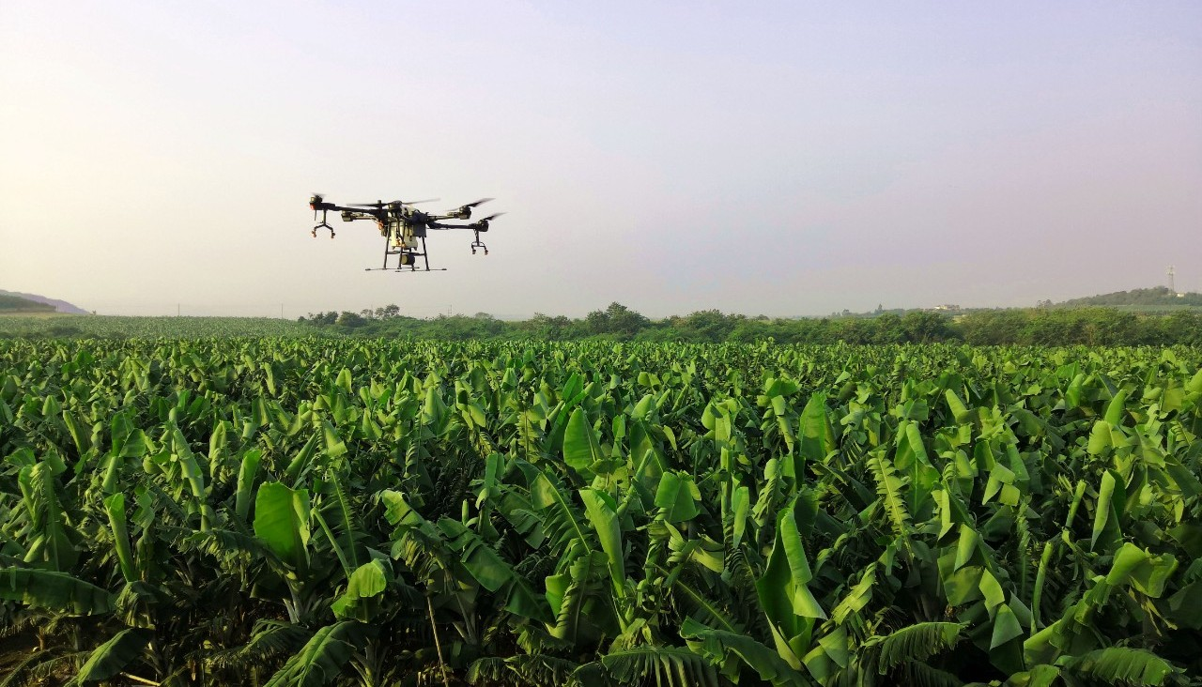

Conclusion

The Agras T16 is equipped with four pumps and eight nozzles for outstanding spraying flow and droplet settling. For treating fruit trees such as bananas, its spraying performance is effective in treating pests and diseases.

“Like many other teams, this is also our first time using T16 to spray banana trees,” shared said Liang, head of the plant protection team. “In terms of operation results, the T16 brought us a lot of surprises. The improvement of efficiency and spraying effect also makes us more confident for future operations. Next time, we will use T16 with the Orchard mode with the Phantom 4 RTK to spray bananas trees.”

Spray Team Introduction
Hainan Zhongnong Aviation Service Technology Co., Ltd. is located in Cangzhou City, Hainan Province, as of June 2016. It has 80 UTC-certified professional pilots, as well as service centers in Yinzhou, Changjiang, Dongfang, Ledong, Chengmai, Sanya, and Qionghai, providing local farmers with accurate, efficient, low-cost, and low-residue aerial spraying services.
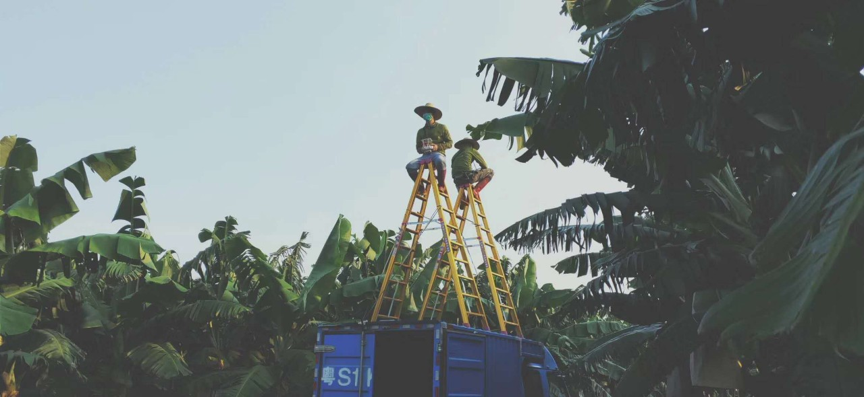
The team has conducted spraying for over 300,000 hectares of fields, covering a wide range of crops and plants, including rice, pumpkin, banana, corn, green soybean, mango, grapefruit, Curcuma zedoary, coconut, and betel nut.

