Spraying Bananas in Dak Lak Province, Vietnam using DJI Agras T16

In recent years, besides familiar trees such as pepper, coffee, cashew, etc., farmers continue to convert crops to fruit trees according to VietGAP standards such as jackfruit, durian, and intercropped are banana, passion fruit in Dak Lak province. Currently, all products are available for harvest and export.
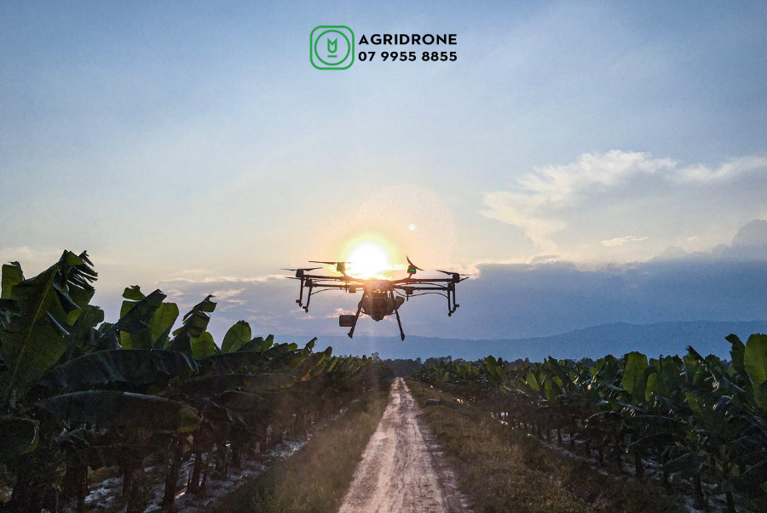

*1. Purpose of the Spray

Vietnam is a tropical country and also home of many precious banana plants. Banana plants are cultivated in large area with high yield. Area under banana cultivation accounts for 19% (2018) of the Vietnam’s total fruit plant area with annual output of about 1.4 million tons. In Dak Lak provinces of Vietnam, Cao Nguyen Iflight Service Center belonging to AgriDrone Viet Nam (AgriDrone.vn) has sprayed 50 ha of bananas for Dakruco Company from in Gia Lai, Vietnam.
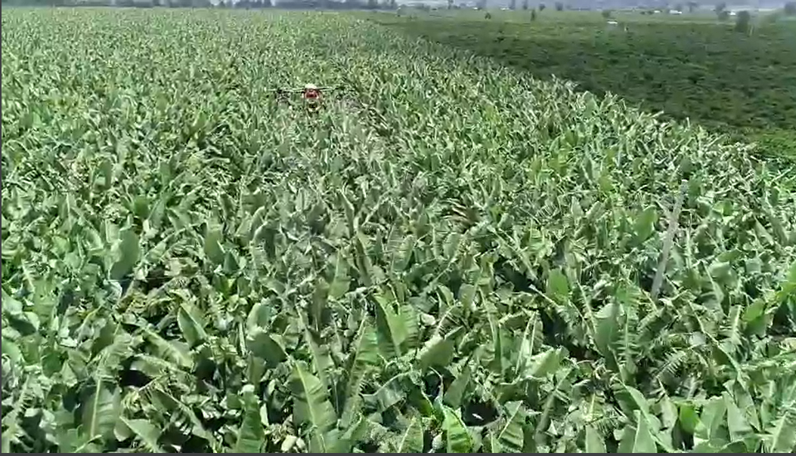

*2. Info of the Environment
Date of Spray | 28/08/2020 | Location | Gia Lai
Type of Terrain | Intercropping with rubber | Temperature(℃) | 30℃
Total sprayed Area(ha.) | 50 ha | Humidity | N/A
Wind speed(m/s) | N/A | Wind direction | N/A

*3. Operation Parameters

Type of Drone | MG-1P | Firmware Version | 0012
Operation mode | Effective | Operation Speed | 100%
Operation height | 2.5m | Line spacing/width | 5m
Liquid amount sprayed per hectare | 20L | Nozzle type | XR110015VS
Suitable for the current weather conditions, which greatly increases the efficiency when combined with the drone.

*4. Info of Chemicals (if you could)
Chemical commercial name | Formulation | Active ingredient and the percentage | Chemical amount (g or ml) used per hectare/
Mexyl MZ |  | Metalaxyl: 8% w/w  Mancozeb: 64% w/w Carriers, additives | 500g/20l/ha
Permecide |  | Permethrin: 200g / liter Additive enough 1 liter | 480ml/20l/ha
Senca Fertilizer |  | Protein (Nts): 11%  Magnesium (MgO): 16%  Humidity: 1% | 1kg/20l/ha
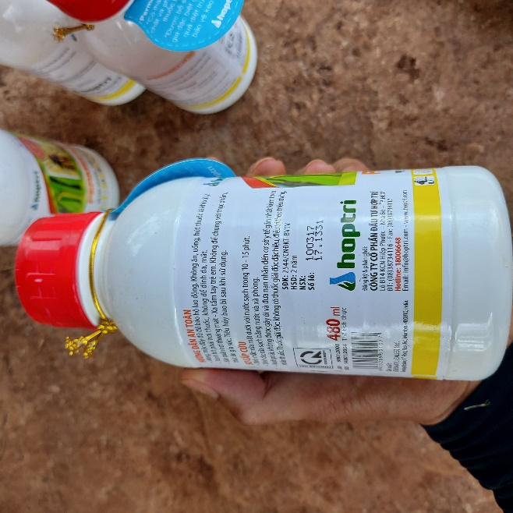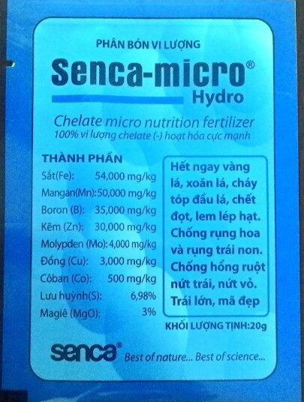

5. Briefly compare the difference between drone, manual, and other traditional equipment in this case (cost, effect, or efficient, any advantages…)
The use of famer workers to spray the bananas has some difficulties such as: In the rainy season, it is difficult to find workers to spray chemicals. The control of pests and diseases has to be more effective in the evening. Small banana trees can spray easily, but it is difficult to spray them when they are growing. The higher of banana is up to 3m and the foliage is dense, so spraying is difficult to ensure effective prevention. In addition, banana trees are grown with high density and growers need weekly use pesticides, fungicides. That's why DJI AGRAS MG-1P is not only responding to prevention requirements but also improves performance dramatically. DJI AGRAS MG-1P is equipped with 4 water pumps and 8 nozzles, outstanding at the flow rate and the penetration rate of the droplet. For fruit trees like banana, there is a good pest control effect after spraying.

*6. Conclusion

We have tested spraying and after seeing the effect, farmers are convinced by the clever and precise spraying ability that we have shown them.
*7. Service team info
Service team name is Cao Nguyen Iflight SC, belonging to AgriDrone Viet Nam (AgriDrone.vn) Our Service team operates in the Central Highlands region of Vietnam. The establishment time up to now is about 4 months. The team has 7 members. Total sprayed Area is over 1000 hectares.
Information:
Contact person: Nguyen Van Thien Vu
Contact info: contact@Agridrone.vn
Hotline: 07 9955 8855
Website: https://agridrone.vn/
YouTube: https://www.youtube.com/c/MayBayNongNghiepDJI/videos

